Bolanle Adisa, Ebun Adebesin, Teah Wilson

Java II

Dr Primo Abena

12/02/2021

**OurQuiz Help doc**

The application is designed to test a student's knowledge on a particular subject. This can be useful in the classes that require constant practice and revision to get properly acquainted with the course material, e.g. programming classes, math classes, etc. Each question is available for a duration of 15 seconds to ensure that the quiz is taken in a timely manner.

The vision is for the application to be used by Professors who want to ensure that students are familiar with the information that has been passed after every lecture. It is a quick quiz that should be completed 5 minutes to the end of each lecture. This is what makes our project very useful and unique!

* We used **polymorphism** to implement JFrame in the code to provide a Graphic User Interface(GUI). AWT/Swing components like Text Field, Radio Button, Labels etc are embedded in the GUI.
* Similar to polymorphism, we made use of **Inheritance** by using classes to inherit the properties, methods and behaviors of objects in our program to implement them from one subclass to another subclass.
* We made use of **multi-dimensional arrays** to store the questions and multiple-choice options that will allow the programmer to easily access the questions and options when need be.
* We made use of **Conditional Statements** like the If...Else statements to perform decision making on logical conditional that the user makes like selecting a button or choosing an option from the multiple choices.
* Additionally, we implemented **Conditional Iterative statements** like for loops to iterate over an if statement that determines if the user’s choice is the right or wrong option in the multiple choice and gives it a score of 10 points for each question.
* Furthermore, **Java Graphics** was used to set the font design like the font type, size, color, etc.

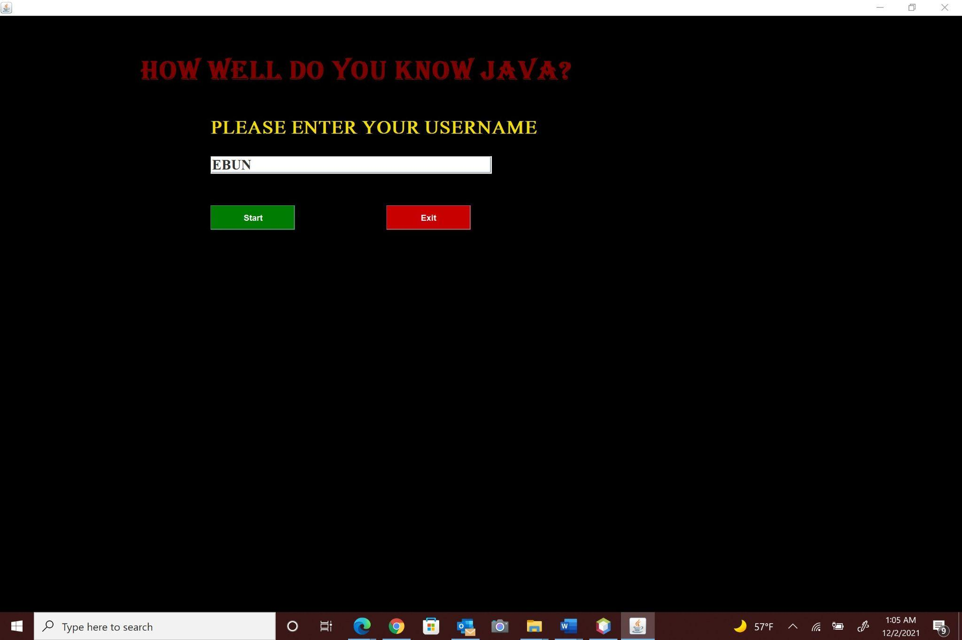

The demo above shows the homepage of the application which allows a user to input their username. It also enables the user to decide between starting the quiz and exiting the application.

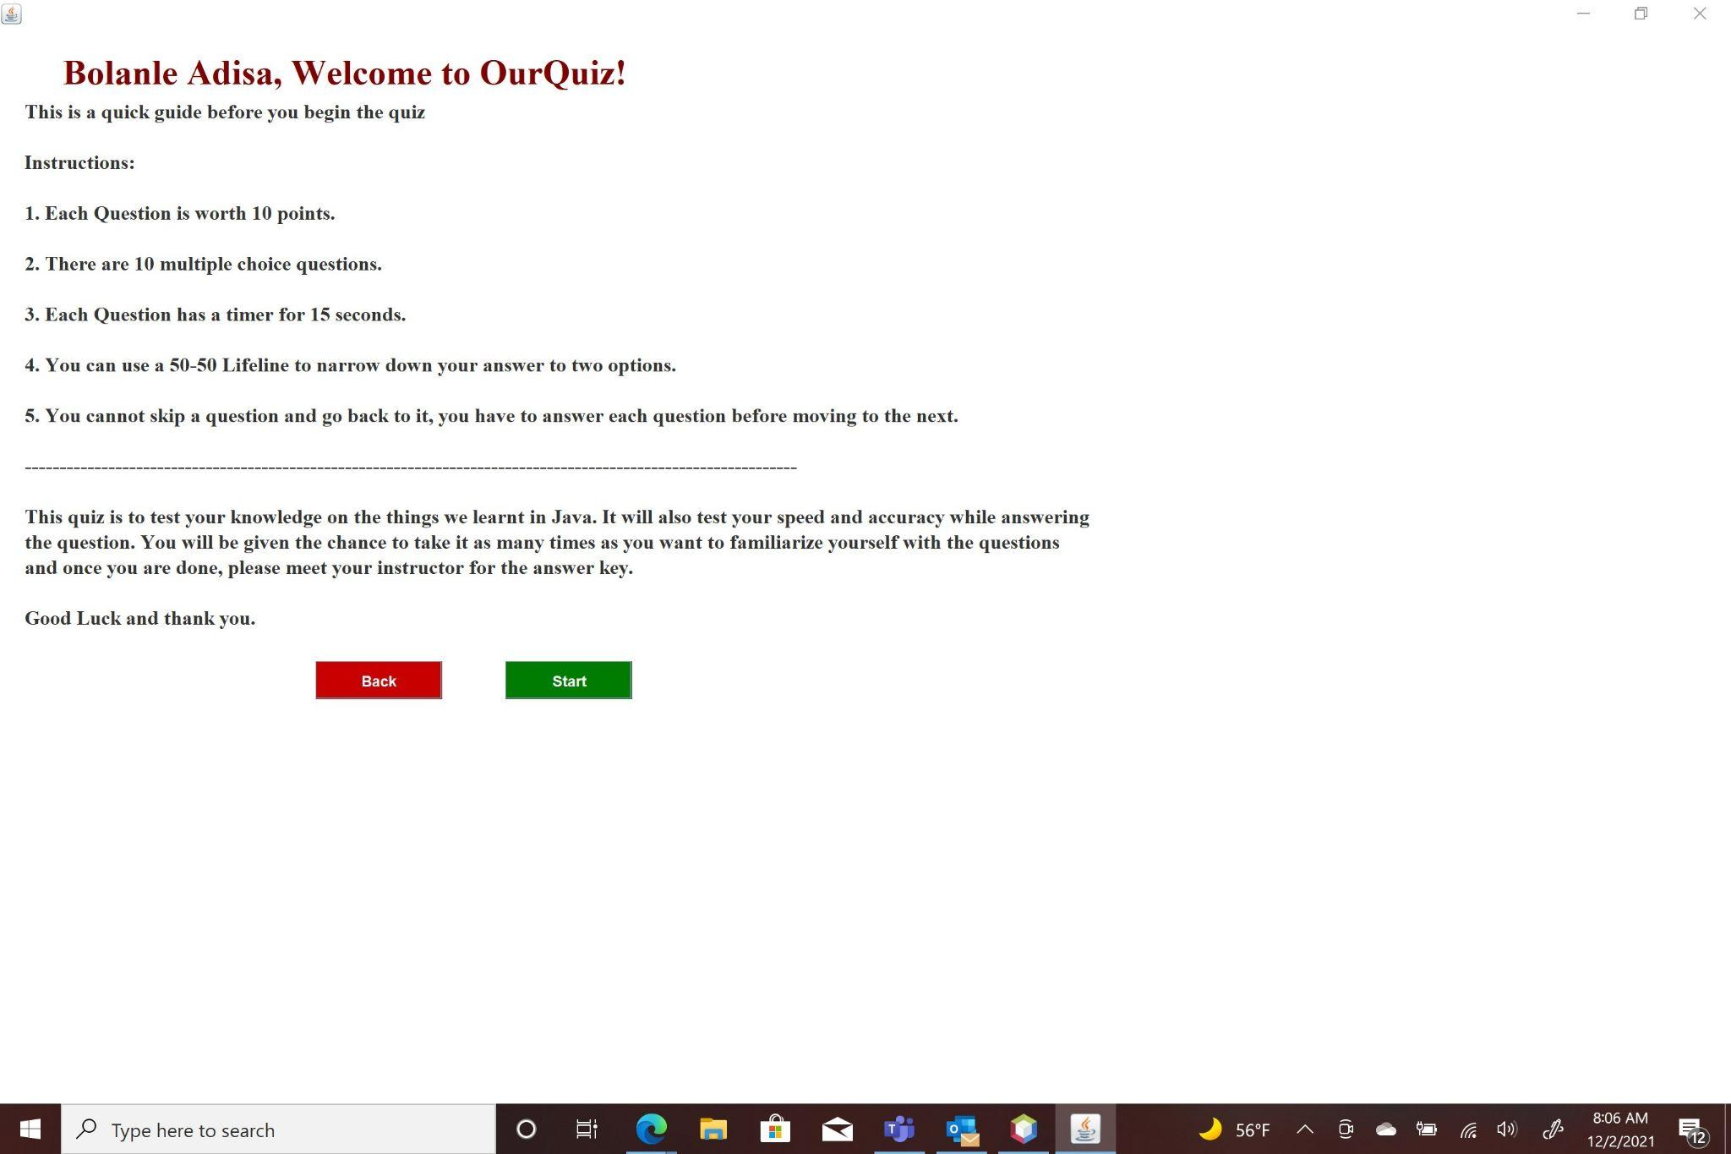

The demo above is a quick guide that goes over what the quiz entails. It tells the user what to expect and gives the user the option of either starting the quiz or going back to the home page. The user can go back to the home page to change their username at this point but once the user starts the quiz, they CANNOT exit it before completion.

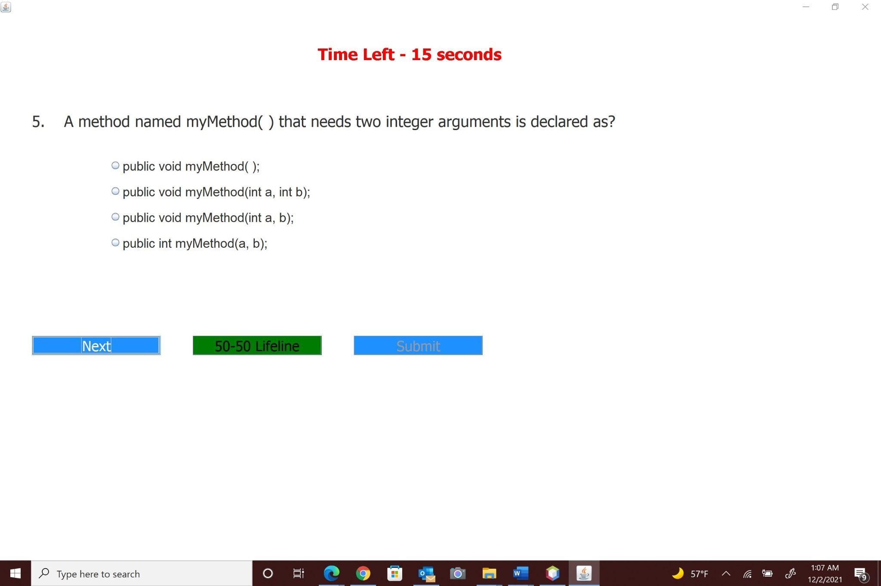

The image above shows a quiz page with all its features. This page has a timer that runs for 15 seconds on each question. It also has the next button, a 50-50 Lifeline button and submit button(which is dormant till the end).

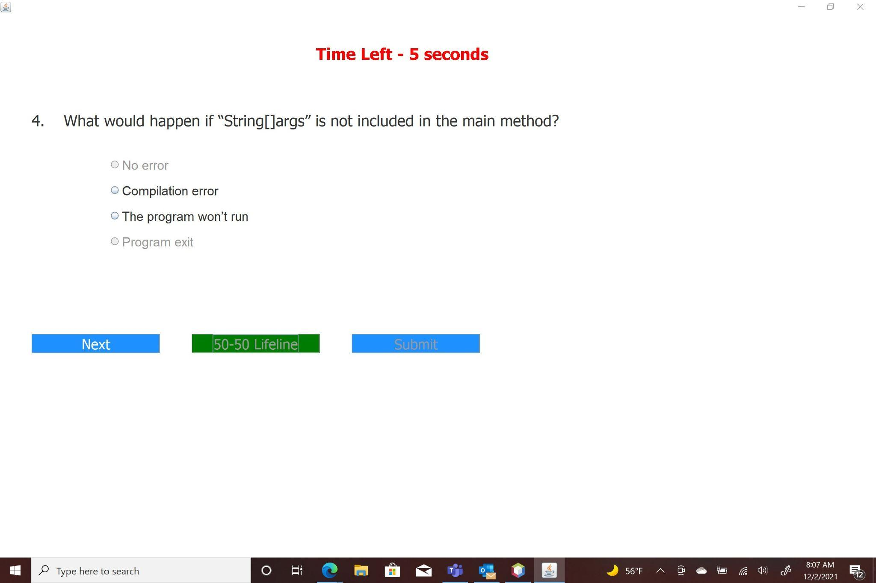

The image above shows what goes on when the 50-50 lifeline button is selected. Two incorrect options are eliminated from the multiple choice to give the user better odds at getting the question right.

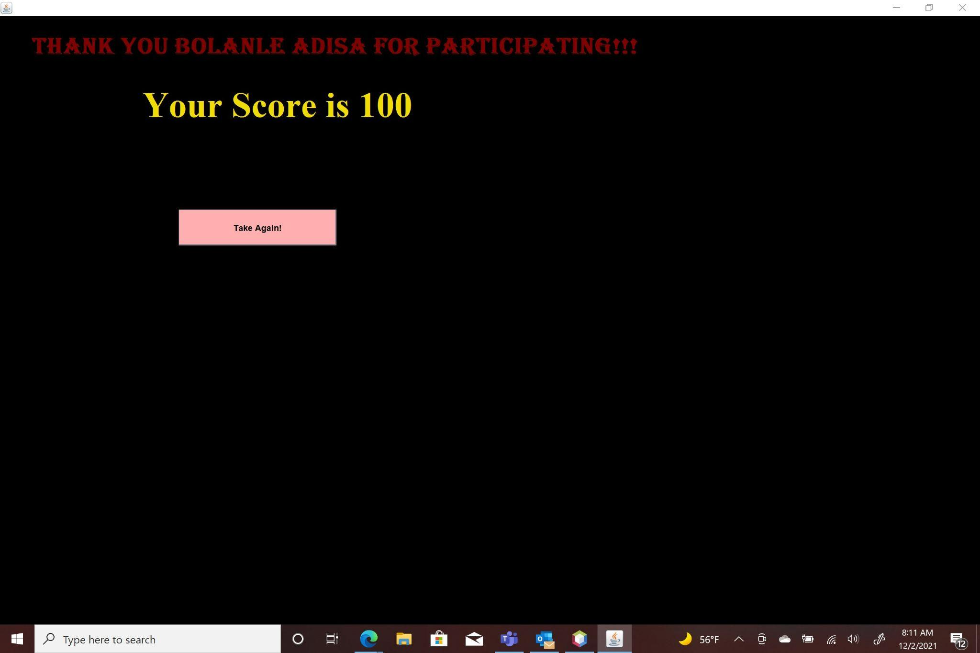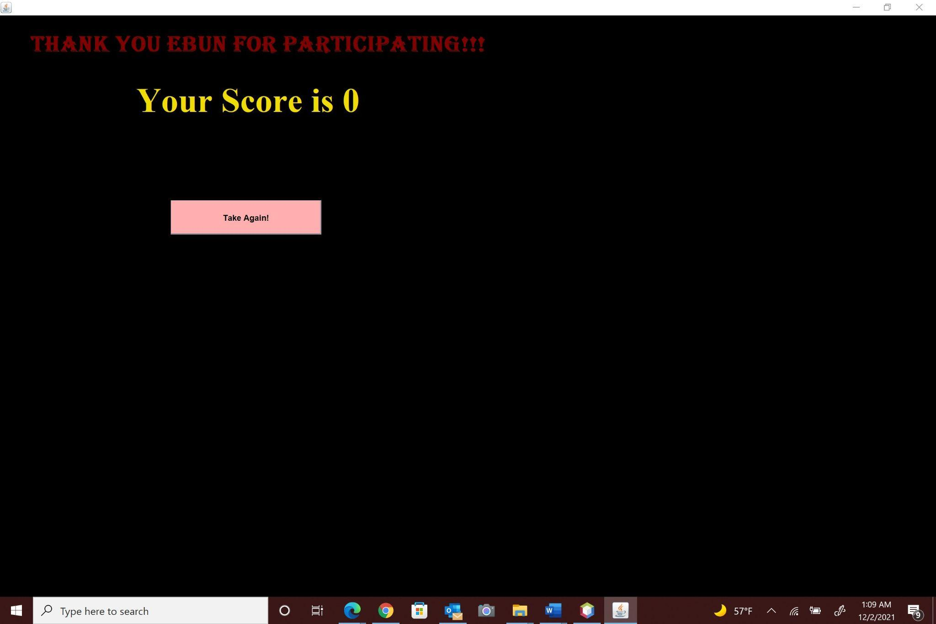

The above demos show an example of what the scoring page looks like. Each question is worth 10 points and the score page shows the accumulation of all the points gained throughout the course of the quiz.